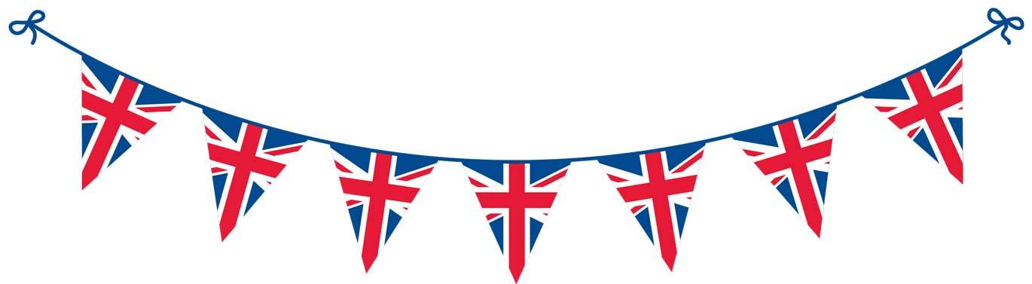

VE Day Quiz

- How many years are we celebrating since VE day in 2020?

- In what year did the UK and France declare war on Germany?
a) 1935
b) 1939
c) 1945

- When did Rationing begin?

- Which of these did the government confiscate from some of the public to help the war effort?
a) Pet Dogs
b) Pet Horses
c) Pet Pigeons

- What was Princess Elizabeth (now Queen Elizabeth II) allowed to do on VE Day?

- How long did it take for Germany to defeat France after invading on 10th May 1940?
a) 6 weeks
b) 6 months
c) 6 years

- Who was Britain’s monarch during World War II?

- Which of these did British people do in response to the German forces bombing during ‘The Blitz’?
a) Turn all the lights on
b) Turn all the lights off
c) Flash torches on and off

- Who is the British singer famous for wartime hit ‘We’ll Meet Again’?

- Where did the royal family stay during the war?
a) Buckingham Palace
b) Sandringham
c) Balmoral Castle

- Which came first VE Day or VJ Day?

- During World War II, Britain was helped by the King’s most loyal enemy aliens. Who were they?
a) French pilots fighting for Britain
b) German soldiers fighting for Britain
c) American cowboys fighting for Britain

- During the war, what nickname did the British give to the Germans?

- Why did some women put gravy on their legs during the war?
a) To keep warm
b) To look like tights
c) To stop it going to waste

- How many people gathered at Piccadilly Circus in London to celebrate VE Day in 1945? (Answer to the closest 10,000)

- How were some German spies rumoured to get into Britain?
a) Dressed as Chefs and coming in by train
b) Dressed as a local Football Team and arriving on bikes
c) Dressed as nuns and parachuting in

- What does VE Day stand for?

- During the war, Winston Churchill would often speak to the US President Roosevelt on a secret telephone, but where was it?
a) In the loo
b) In the basement
c) In the middle of a field in oxford

- Where else in London did crowds gather to celebrate VE day?

- On what date was Pearl Harbour attacked by the Japanese?
a) December 7th 1940
b) December 7th 1941
c) December 7th 1942

- What date did Adolf Hitler allegedly commit suicide in his Berlin bunker?

- How many gas masks were issued during the war?
a) Over 38 million
b) 20 million
c) 10 million

- When did Rationing cease?

- How many children were evacuated during World War II?
a) 250,000
b) 500,000
c) Over a million

- Which Country stayed neutral in the War?

- How long did rationing last for?
a) 4 years
b) 8 years
c) 14 years

- How old did you have to be to be able to sign up for the war?

- How did people know there was an air raid coming?
a) Radio announcement
b) Air Raid Wardens ran through the street shouting
c) Sirens sounded

- Who was Prime Minister at the beginning of World War II?

- Who was Britain’s main ally during the war?
a) France
b) USA
c) Sweden

