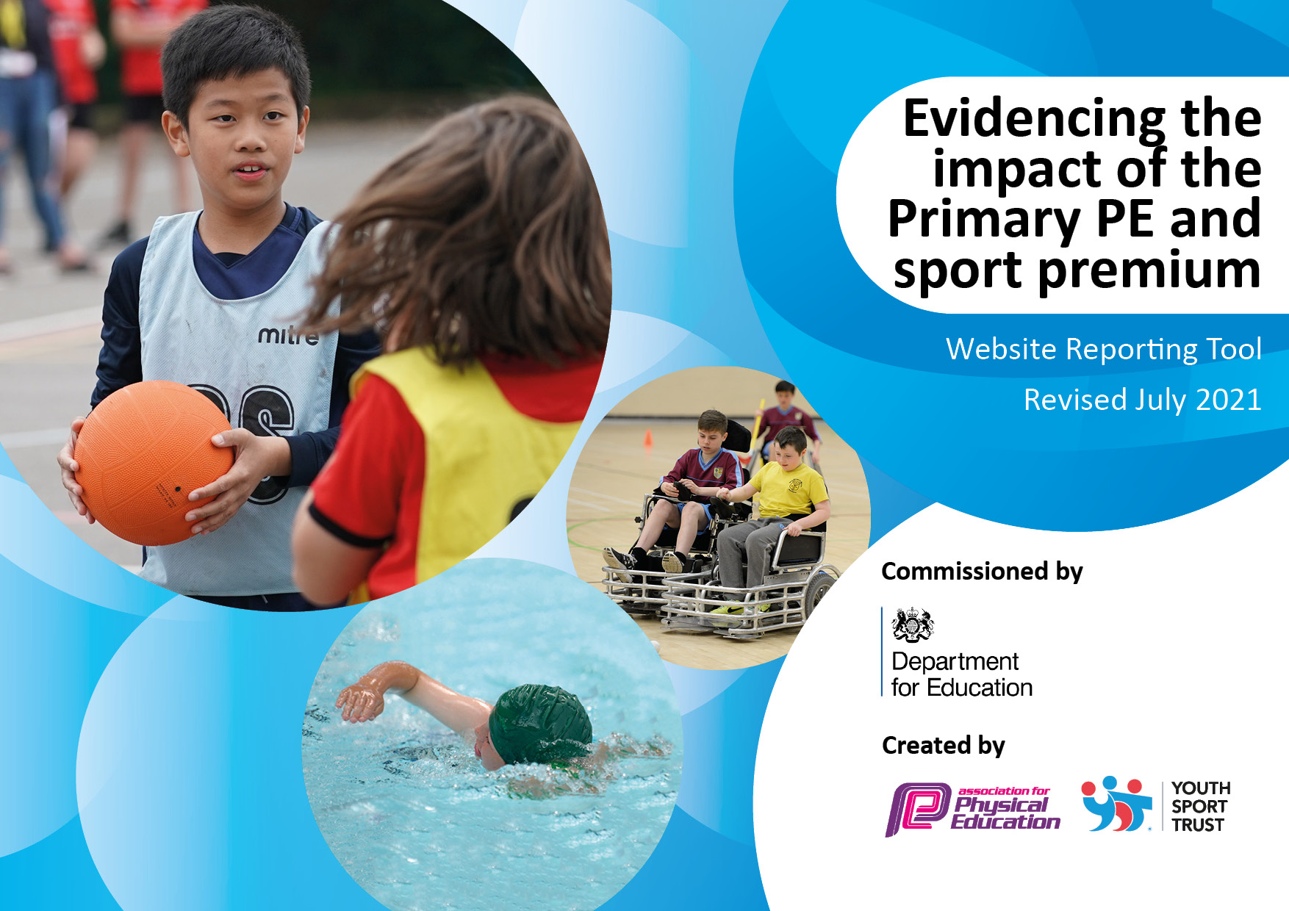
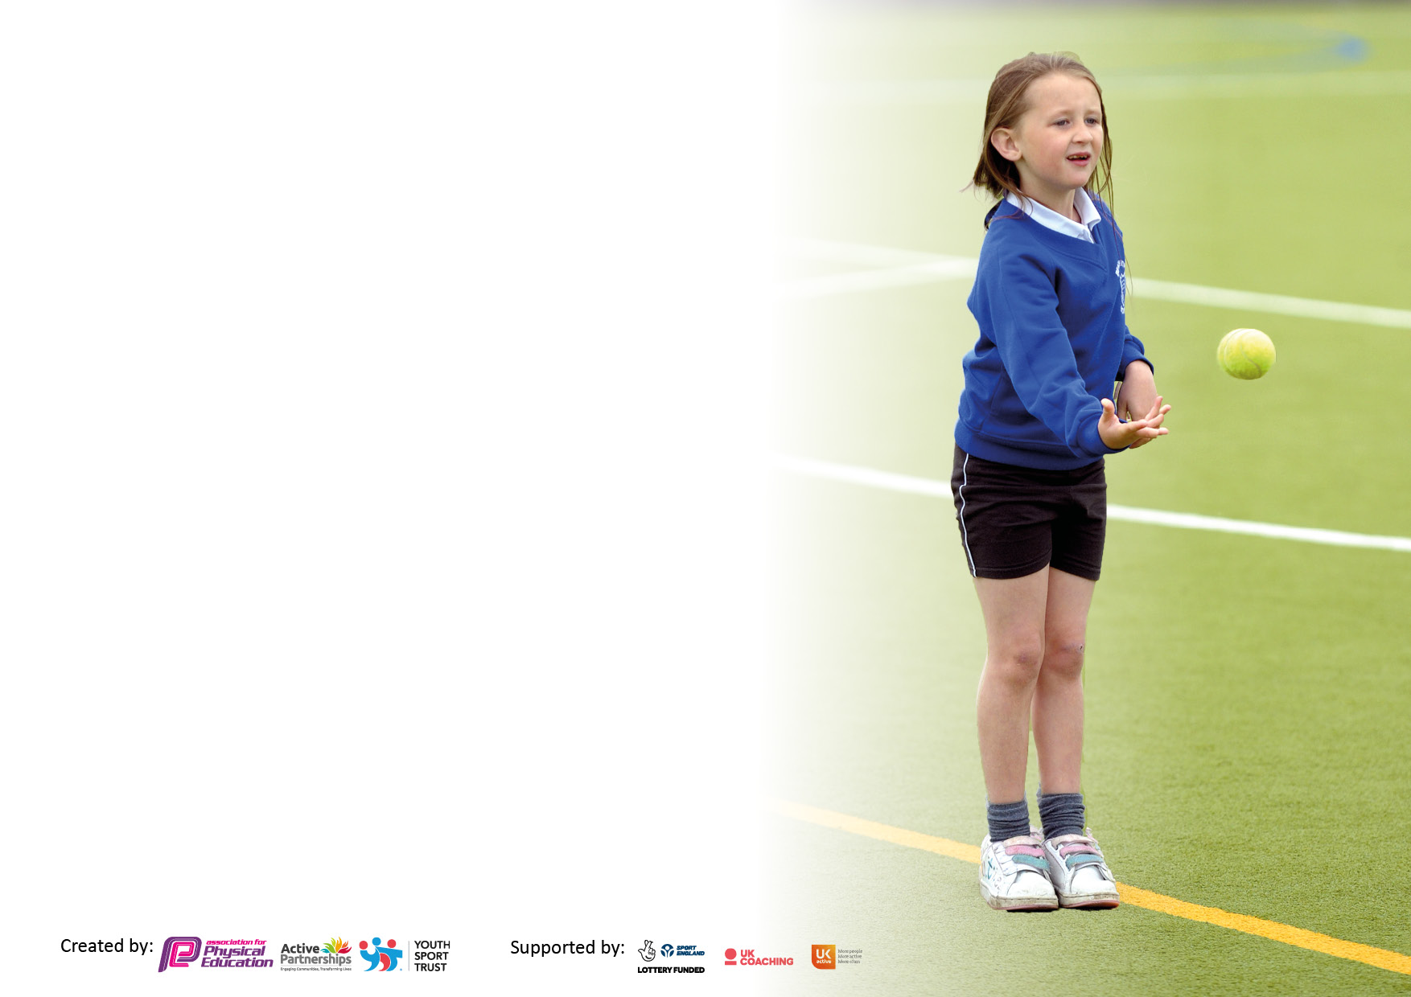

It is important that+ your grant is used effectively and based on school need. The Education Inspection Framework makes clear there will be a focus on ‘whether leaders and those responsible for governors all understand their respective roles and perform these in a way that enhances the effectiveness of the school’.

Under the Quality of Education Ofsted inspectors consider:
Intent - Curriculum design, coverage and appropriateness
Implementation - Curriculum delivery, Teaching (pedagogy) and Assessment
Impact - Attainment and progress

To assist schools with common transferable language this template has been developed to utilise the same three headings which should make your plans easily transferable between working documents.

Schools must use the funding to make additional and sustainable improvements to the quality of Physical Education, School Sport and Physical Activity (PESSPA) they offer. This means that you should use the Primary PE and sport premium to:

- Develop or add to the PESSPA activities that your school already offer
- Build capacity and capability within the school to ensure that improvements made now will benefit pupils joining the school in future years
- The Primary PE and sport premium should not be used to fund capital spend projects; the school’s budget should fund these.

Pleasevisitgov.ukfortherevisedDfEguidanceincludingthe5keyindicatorsacrosswhichschoolsshoulddemonstrate animprovement.Thisdocumentwillhelpyoutoreviewyourprovisionandtoreportyourspend.DfEencouragesschools to use this template as an effective way of meeting the reporting requirements of the Primary PE and sport premium.

We recommend you start by reflecting on the impact of current provision and reviewing the previous spend.

Schools are required to publish details of how they spend this funding, including any under-spend from 2019/2020, as well as on the impact it has on pupils’ PE and sport participation and attainment. All funding must be spent by 31st July 2022.

We recommend regularly updating the table and publishing it on your website throughout the year. This evidences your ongoing self-evaluation of how you are using the funding to secure maximum, sustainable impact. Final copy must be posted on your website by the end of the academic year and no later than the 31st July 2021. To see an example of how to complete the table please click HERE.
Created by: Supported by:

Details with regard to funding
Please complete the table below.

Total amount carried over from 2019/20 | £16,690
Total amount allocated for 2020/21 | £16,900
How much (if any) do you intend to carry over from this total fund into 2021/22? | £14,607
Total amount allocated for 2021/22 | £16,860
Total amount of funding for 2021/22. To be spent and reported on by 31st July 2022. | £31,467
Swimming Data
Please report on your Swimming Data below.

Meeting national curriculum requirements for swimming and water safety.

N.B. Complete this section to your best ability. For example you might have practised safe self-rescue techniques on dry land which you can then transfer to the pool when school swimming restarts.
Due to exceptional circumstances priority should be given to ensuring that pupils can perform safe self rescue even if they do not fully meet the first two requirements of the NC programme of study
What percentage of your current Year 6 cohort swim competently, confidently and proficiently over a distance of at least 25 metres?  N.B. Even though your pupils may swim in another year please report on their attainment on leaving primary school at the end of the summer term 2020.  Please see note above | 100%
What percentage of your current Year 6 cohort use a range of strokes effectively [for example, front crawl, backstroke and breaststroke]?  Please see note above | 100%
What percentage of your current Year 6 cohort perform safe self-rescue in different water-based situations? | 80%
Schools can choose to use the Primary PE and sport premium to provide additional provision for swimming but this must be for activity over and above the national curriculum requirements. Have you used it in this way? | Yes

Action Plan and Budget Tracking
Capture your intended annual spend against the 5 key indicators. Clarify the success criteria and evidence of impact that you intend to measure to evaluate for pupils today and for the future.

Academic Year: 2021/22 | Total fund allocated: £31, 467 | Date Updated: 21 July 2022
Key indicator 1: The engagement of all pupils in regular physical activity – Chief Medical Officers guidelines recommend that primary school pupils undertake at least 30 minutes of physical activity a day in school |  |  |  | Percentage of total allocation:
 |  |  |  | 33 %
Intent | Implementation |  | Impact
Your school focus should be clear what you want the pupils to know and be able to do and about  what they need to learn and to  consolidate through practice: | Make sure your actions to achieve are linked to your intentions: | Funding spent academic year 2021/22: | Evidence of impact: what do pupils now know and what can they now do? What has changed?: | Sustainability and suggested next steps:
To ensure that all children understand the importance of and participate in at least 30 minutes of physical activity per day  To encourage more children to travel to school via a form of physical activity  To increase the uptake of children attending physical/sports clubs all year round | Develop annual timetable and increase the number of extra-curricular/after school activities available throughout the school year  Set up a walk to school initiative.  Introduce new outdoor activities per term (only available for that term)  Continue with Monday mile, Friday dance, active collective worships, super movers etc.  Ensure all children have appropriate kit to partake in PE | Track £10,191  PE kits £175 | A track has been installed so all children can access a daily mile whatever the weather  Physical activity has increased and children have increased all weather areas to utilise daily  Pupils feel proud to wear their kit and represent their school  Squad numbers have increased and an Under 9 team started | Mile markings and activity spots added to track
Key indicator 2: The profile of PESSPA being raised across the school as a tool for whole school improvement |  |  |  | Percentage of total allocation:
 |  |  |  | 8%
Intent | Implementation |  | Impact
Your school focus should be clear what you want the pupils to know and be able to do and about  what they need to learn and to  consolidate through practice: | Make sure your actions to achieve are linked to your intentions: | Funding spent academic year 2021/22: | Evidence of impact: what do pupils now know and what can they now do? What has changed?: | Sustainability and suggested next steps:
To evidence and celebrate successes in Sport and PE across the school  To organise an aspirational event to encourage and motivate children to achieve full their full potential | Implement PE boards around school that display children’s work and achievements.  Celebrate sporting and PE successes every week during celebration assemblies.  Identify gifted and talented children, challenge and signpost them to relevant school and community clubs.  Organise a visit and PE session from an athlete and/or trip to visit spectate sport  Through discussion with children make links with a sports team and follow their journey  Include physical activity in other areas of the curriculum | O2 Play off finals £1,300  Display boards £488  Olympic day £660 | Children have raised aspirations having seen sport played at the highest level  Sporting achievements both inside and outside of school are visibly celebrated throughout the school  All children in school accessing professional athletics facilities and participating in a day together to raise aspiration and inspire pupils

Key indicator 3: Increased confidence, knowledge and skills of all staff in teaching PE and sport |  |  |  | Percentage of total allocation:
 |  |  |  | 21%
Intent | Implementation |  | Impact
Your school focus should be clear  what you want the pupils to know  and be able to do and about  what they need to learn and to  consolidate through practice: | Make sure your actions to  achieve are linked to your  intentions: | Funding spent academic year 2021/22: | Evidence of impact: what do | Sustainability and suggested
 |  |  | pupils now know and what | next steps:
 |  |  | can they now do? What has
 |  |  | changed?:
To increase pupils’ achievement in PE through delivery of high-quality lessons led by qualified coaches and teachers  To maintain 100% of pupils leaving school being able to swim 25m  To ensure all staff have access to and are confident in following PE planning and progression documents | Have a qualified level 2+ coach to develop 100% of KS2 PE lessons and 50% of KS1 lessons  Training and support provided by a qualified swimming coach to enhance existing provision  CPD available to staff | £6,410  £284 | Children participating and developing higher level skills  Swimming teacher to provide intensive support resulting in all pupils swimming 25m before leaving school | PE and Sport Teaching Assistant to support high quality coaching  Further swimming qualifications for PE and Sport Teaching Assistant
Key indicator 4: Broader experience of a range of sports and activities offered to all pupils |  |  |  | Percentage of total allocation:
 |  |  |  | 30%
Intent | Implementation |  | Impact
Your school focus should be clear | Make sure your actions to | Funding spent academic year 2021/22: | Evidence of impact: what do | Sustainability and suggested
what you want the pupils to know | achieve are linked to your |  | pupils now know and what | next steps:
and be able to do and about | intentions: |  | can they now do? What has
what they need to learn and to |  |  | changed?:
consolidate through practice:
To develop children’s understanding and knowledge of sports and games To increase children’s confidence and resilience when tackling new activities | Introduction and participation to those sports which are less familiar to pupils through:  - Sport2Day enrichment days  - Introduction of new sports to curriculum  - Cross-curricular links where applicable | Sport2Day Enrichment £2,050  New Equipment £1,615  Outdoor adventure £5,642 | Children have a broad and varied range of activity including Tchoukball, Khabaddi, water sports, climbing etc.  All children respond positively during pupil interviews about PE  All children can identify a sporting activity they enjoy | Continued provision from Sport2Day  PE and Sport Teaching Assistant offering additional lunchtime and after school clubs

Key indicator 5: Increased participation in competitive sport |  |  |  | Percentage of total allocation:
 |  |  |  | 8%
Intent | Implementation |  | Impact
Your school focus should be clear | Make sure your actions to |  | Evidence of impact: what do | Sustainability and suggested
what you want the pupils to know | achieve are linked to your |  | pupils now know and what | next steps:
and be able to do and about | intentions: |  | can they now do? What has
what they need to learn and to |  |  | changed?:
consolidate through practice:
To ensure that all children experience termly competition and represent the school at least once by the time they leave year 6  To increase the number of children taking part in local sports clubs | Organise termly house competitions ran and organised by house captains supported by staff  Participate in Sport2Day external competitions (100% of KS1 children to compete and 75% of KS2)  Enter 3 teams into the Norfolk Basketball League  Develop links and signpost children to join local clubs (Holbeach & Fenland, Long Sutton Hockey etc.) | £1,025 (Sport2Day Comp)  Basketball England and NYBL registration and fees £624  Table tennis fees £436  Gymnastics competition equipment £550 | All pupils in KS1 and KS2 have represented the school at a sporting event  3 teams have been entered into the Norfolk Basketball League; the U11 squad finishing 3rd overall  Tydd Topspin players now participate in the Wisbech Table Tennis League

Signed off by
Head Teacher:
Date:
Subject Leader:
Date:
Governor:
Date:

