Tydd St Mary Church of England Primary School

Positive Behaviour Policy 2020

Positive Behaviour is a necessary part of the provisions we make in Tydd St Mary to create and maintain a safe and nurturing working environment in which all members of the school community feel secure and can learn and flourish. We have high expectations for our children- both their learning and their behaviour.

Aims of our Positive Behaviour Policy

- To encourage a calm, purposeful and happy atmosphere within school
- To foster positive, caring attitudes towards everyone where achievements at all levels are valued
- To encourage increasing independence and self-discipline so that each child learns to accept responsibility for their own behaviour
- To have a consistent approach to behaviour throughout the school with parental co-operation and involvement
- To raise children’s self-esteem
- To provide clear boundaries for acceptable behaviour to ensure physical and emotional safety and
- To help children, staff and parents have a sense of direction and a feeling of common purpose

Teaching Positive Behaviour

At Tydd St Mary’s we believe that positive behaviour in children stems from learning core skills and abilities including:-

- Independence and organisation
- Self-image and self-esteem
- Motivation
- Reflection and self-control
- Attention
- Perseverance
- Fairness

- Co operation with adults
- Collaboration with other children
- Sociability and
- Empathy
- Honesty

We believe that all staff at school have a responsibility to actively help children develop these core skills and abilities. They can be taught throughout the school day by:-

- Staff modelling the skills and abilities directly
- Setting appropriate boundaries for children’s behaviour
- Showing empathy and understanding of children
- Listening to children
- Showing respect and understanding to everyone in the school community
- Providing feedback in an informative way to children
- Using positive consequences to encourage the learning of appropriate behaviour
- Using negative consequences to discourage the learning of inappropriate behaviour and
- Teaching the skills and abilities through PSHE, circle time and assembly themes

Rules, Routines and Mottos

The school’s Behaviour Policy should be reviewed annually. Whole school mottos should be negotiated and agreed by the school community. These mottos should form the basis of classroom, school and playground ground rules and routines. Our school mottos are:-

WE SHOW CARE AND RESPECT FOR OTHER PEOPLE, THEIR BELONGINGS AND THE ENVIRONMENT

WE ARE PROUD OF OURSELVES AND OUR SCHOOL
WE TRY OUR BEST TO BE THE BEST

Each class should work together to establish ground rules, which allow the classroom to operate effectively within a safe, happy and busy learning environment. These will be supported in Key Stage 2 by the ‘Good to be Green’ reward system. Playground rules are established in the same way so that the playground is a safe, happy and fair place to be.

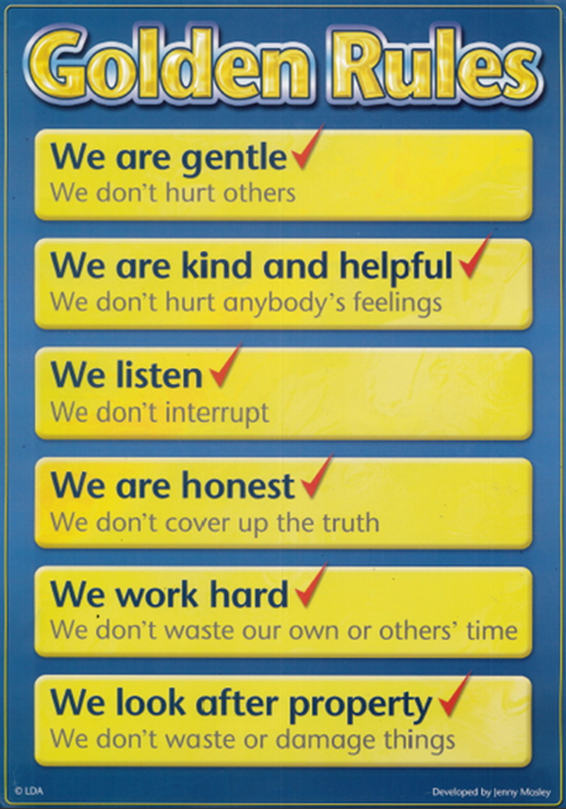
Specific School Rules

We are gentle, kind and helpful

We listen

We are honest

We work hard

We look after property

WE KNOW THAT WE OWN OUR OWN BEHAVIOUR!

These are displayed in pictures and texts around the school.

Responsibilities

Staff Responsibilities

- To treat all children fairly and with respect
- To help all children to develop their full potential
- To provide a challenging, interesting and relevant curriculum
- To create a safe and pleasant environment both physically and emotionally
- To use positive and negative consequences clearly and consistently
- To be a good role model
- To form positive relationships with parents and children
- To recognise and value the strengths of all children and
- To offer a framework for teaching the personal, social and emotional skills and abilities that underpin the school’s behaviour policy

Parents’ Responsibilities

- To make children aware of appropriate behaviour
- To encourage independence and self-discipline
- To show an interest in all their child does in school
- To support the school in implementing this policy and
- To be aware of the school rules

Children’s Responsibilities

- To do their best
- To contribute to their own learning
- To treat others, their belongings and the environment with respect
- To show consideration for others
- To consider the effects of their actions on others

Positive Consequences (Rewards)

At Tydd St Mary’s we believe that children should be encouraged to behave well and work hard. We use a number of positive consequences to do so. Whilst our aim is that children should work and behave well for the pleasure of the task, we recognise that rewards are sometimes necessary and appropriate. We use the following positive rewards:-

- Non-verbal rewards such as a thumbs up sign or a smile
- Praise
- Showing work to another teacher and to the headteacher
- Stickers
- Certificates
- Star of the week
- Letter home to parents sharing the example of good work or behaviour
- Displaying work
- Weekly whole school Achievement Assembly

In Key Stage 2 the ‘Good to be Green’ behaviour scheme is used to communicate the consistent and fair approach to the children. Rewards are awarded daily, weekly, termly and annually to those children who demonstrate ‘green’ behaviours.

We believe it is essential that all children are able to receive positive encouragement and have a fair chance to enjoy the positive rewards listed. Children’s success, both in their work and behaviour should be measured against their previous performance rather than against that of other children in their class.

Negative Consequences (Sanctions)

In order to discourage children from behaving badly we believe it is important to teach them positive behaviours. If a child misbehaves staff should ask them to stop the behaviour and should discuss the incident with all those involved. Children should always be given clear choices and the consequences of those choices. Staff should encourage the children to try to resolve disputes themselves and to take responsibility for their own actions. We strongly believe that whilst persistent or serious misbehaviour needs careful monitoring and recording, every child must feel that every day is a fresh start.

At Tydd St Mary’s we do this via a system of logical consequences designed to teach children that there is a consequence to inappropriate behaviour. Such consequences should be linked to the inappropriate behaviour and should be set within the context of the school community. In the following tables we have listed inappropriate behaviours and a range of negative consequences which may be used, as deemed necessary
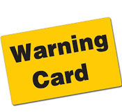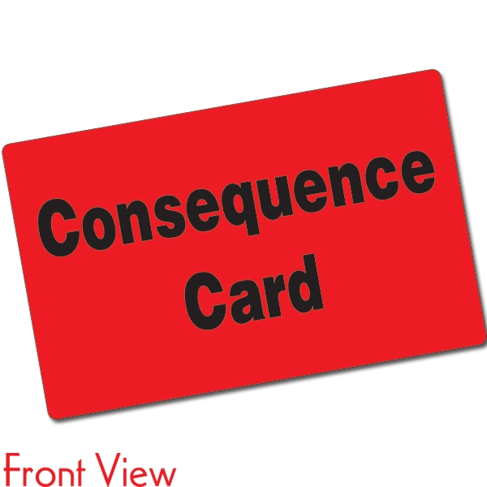

Table 1 Behaviours

Low Level | Moderate Level | Serious Level
Fidgeting / fiddling  Telling tales  Dropping litter  Noisy eg talking/shouting  Failing to keep on task  Unkind remarks  Bad language (one off)  Time wasting  Telling lies  Running in school  Pushing in line  Borrowing without permission  Leaving work area untidy  Any persistence of low level behaviours would move into the moderate level | Consistently shouting out  Poor effort  Distracting others  Unprepared for work  (continuously)  Fighting  Bad language (persistent)  Rough play  Stealing  Disregarding supervisors  Threatening/aggressive behaviour  Refusal to co operate  Vandalism – graffiti etc  Forms of discrimination  Repeated incidents of any moderate behaviours – Head teacher informed. | Serious assault  Vandalism eg extreme damage to school property  Serious physical/verbal threats made to staff  Racism  Bullying  Drugs/solvents  Violent outbursts- verbal/physical  Leaving school without permission

Table 2 Sanctions / Procedures

Low Level | Moderate Level | Serious Level
Frown  Verbal  Withdrawing attention  Repeat activity properly  Sit alone/stand out  Reward others  Warning- yellow card  Related sanction e.g. completing work, cleaning up mess | Consequence- red card  Sit alone desk  Loss of break time/ lunchtime  Extra work  Buddy system  Reflect and write  Letter to parents  Loss of privileges  Referred to head teacher  Behaviour timetable using the traffic light system | Isolation from peers for the rest of the session  Head teacher meeting with parents  Involve SENCO  Education Plan/PSP  Weekly behaviour report  Involve outside agency  Exclusion- either fixed term or permanent

Involving Parents

In keeping with the aims of our school ethos, we encourage parents to take an active part in the life of the school. We believe this is essential to establishing trusting relationships which allow us to work together in partnership to teach all children positive behaviour.

Procedures in place when there is concern about a child’s behaviour

If a child displays inappropriate behaviour of a moderate level he/she will be asked to reflect and write about what went wrong and to suggest ways in which the behaviour can be improved or avoided in future. Parents will be asked to sign this agreement. Should a child’s behaviour continue to give concern he may be referred twice to the Head teacher. At first referral the class teacher will contact the parents to discuss the problem. At the second referral the head teacher will contact the parents. Serious incidents may be referred directly to the Head teacher. At each stage, the referral system allows the teacher to find out if there are any factors that may be contributing to the child’s behaviour.

Where concerning behaviour continues in spite of all of the above procedures the child will be referred to the Special Needs Co-ordinator who will work with the class teacher to develop an appropriate education plan which will be discussed with the child and the parents.
The plan will be reviewed regularly and updated appropriately. Where necessary, referral will be made to a specialist teacher or outside agency (BOSS) in line with the school’s Special Educational Needs policy and the Code of Practice.
In very exceptional circumstances, and when all channels have been exhausted, the procedures for exclusion will be initiated, following County guidelines. Only the Head teacher has the authority to exclude a pupil from school.

In-service Training Needs

In keeping with the school’s development plan, in–service training needs will be identified and addressed within the school’s financial constraints. In addition, we will endeavour to ensure that staff are made aware of all relevant and available in- service training.
.

Race Equality and Equal Opportunities

We believe that it is important to prepare our children for life as citizens of a multi-ethnic society in which there should be race equality, harmony and an absence of racism. We are committed to tackling racial discrimination and to promoting equality of opportunity. Any incidents of a racist nature will be dealt with following our Positive Behaviour Policy.

Evaluation

The effectiveness of the policy will be measured by:-
- Informal reports from staff/parents/pupils
- Feedback from pupil and parent questionnaires
- A reduction in the number of children being sent to the Head teacher
- A reduction in the number of children referred to external agencies

Signed Headteacher:

Signed Chair of Governors:

Date:

Review Date: July 2021

