**Tydd St. Mary Church of England School**

**Geographical knowledge and skills**

* Tourism can be abroad or in the country you live in
* There are many advantages to tourism – traditional clothing and art can be appreciated and this helps keep traditions alive
* Tourists spend money in local shops, helping the economy
* Disadvantages can be the damage, wear and tear that tourists make during their holiday
* Higher levels of travelling equates to an increase in pollution
* Many people are attracted to the coastal regions of the UK – North Norfolk coast, South West Coast
* Some people choose to holiday in a European Country – Spain, France, Turkey
* use the 8 points of a compass, 4- and 6-figure grid references, symbols and key
* Use atlases, digital maps and ordinance survey maps

**Knowledge Organiser**

**Key Vocabulary**

**Tourism** – where people travel to a place for pleasure, such as a holiday.

**Tourist** – the people who travel to place for pleasure

**Destination –** the place you are going to

**Eco-tourism** is about buildings, roads, farms, etc. Things that have been made by humans.

**Pollution** A person who moves here from another country

**Conservation** To do with more than one country

**Sustainable tourism** - an important, large, or high performing city.

**Environmentally friendly** A person who moves to another part of the country, or another country, often to find work.

**Pilgrimage** Journey sometimes related to religion

**Physical geography** is about the natural World; mountains, seas, rivers, forests etc.

**Human features** things that have been man-made – human influence

**Attraction** Things that make people what to visit certain places

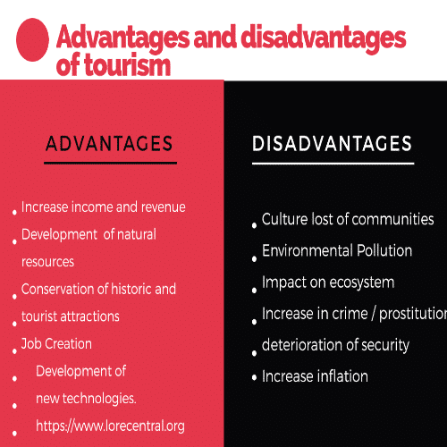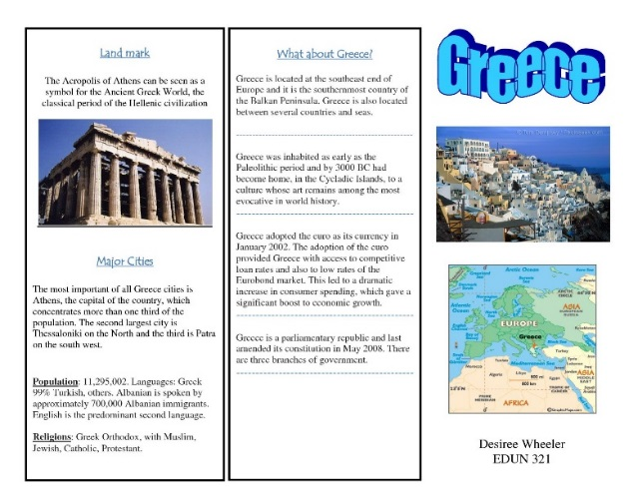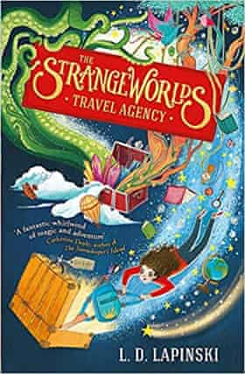

**Holiday**

**Kingfishers: Tourism**

Tourists can be beneficial bringing money to an area and providing locals with jobs.

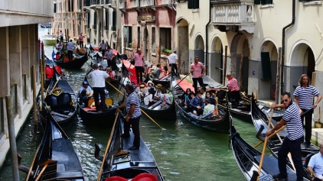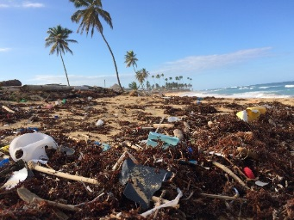

Sometimes tourists can cause problems and pollution

Travel brochures and leaflets are used to advertise human and physical features, that tourists might like to visit.