Ceramics
 | EYFS | KS1 | LKS2 | UKS2
Focus Objectives | Experience playdough and clay  Roll, knead, pat, poke, squeeze, pull and imprint  Use cutters and tools accurately | Roll a clay tile  Make holes in clay  Imprint, make marks & stamp  Use slip to join clay  Create surface texture | Make a thumb, pinch and coil pot  Use slip effectively  Explore embossing/imprinting, engraving, beating and combing as methods of decoration  Join pinch pots to form a hollow shape  Make a figure from 1 piece of clay Explore carving | Roll clay to make a slab pot  Explore casting with plaster of Paris  Carve from clay
Key Vocabulary | Roll, knead, pat, poke, squeeze pull, imprint | Stamp, make marks, tile, figure, slip, texture, imprint, roll, | Thumb pot, pinch pot, coil, embossing, engraving, beating, brushing, combing, hollow, carve, | Slab pot, casting, carve,
Resources | Rolling pins, playdough, cutters, candles, face pieces, clay, modelling tools, clay boards, playdough moulds, | Clay, rolling pins, clay boards, modelling tools, impress tools, clay slip, pencils, | As KS1 + soap | As KS1 + plastic bowls, sand, plaster,
Focus Artists |  | Chris Gryder | Anthony Gormley | Rachel Whiteread, Terracotta Army (artist unknown), Easter Island statues (Rapa Nui people),
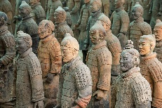
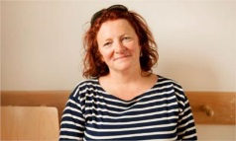
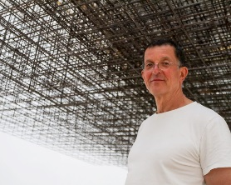
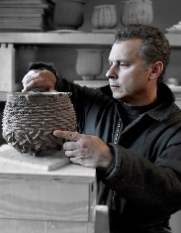

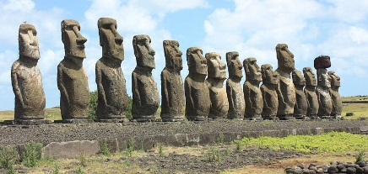

Collage
 | EYFS | KS1 | LKS2 | UKS2
Focus Objectives | Collect and sort materials  Select resources for a certain purpose  Use scissors accurately  Choose best joining methods  Use glue cleanly and effectively | Explore controlled & random tearing  Cut strips, shapes, curves & fringe  Create simple pictures  Collage with natural & found objects  Explore overlapping  Contribute to a class resource collection | Use sketchbooks to gather personal collections  Choose materials for a purpose  Copy and match environmental textures  Explore gluing, pinning and pasting  Explore folding, crumpling, tearing, cutting and pleating techniques  Link collage to paintings  Work in a mixed media style | Understand the importance of balance, contrast and pattern  Create a photomontage  Explore frottage  Work on different scales and proportions  Combine painting with collage  Explore lamination, Modroc and collage for surface texture  Create a mixed media collage
Key Vocabulary | Collect, sort, scissors, cut, glue, | Tear, strip, curve, cut, snip, fringe, fold, overlap, pleat, crumple, natural, found, | Glue, pin, paste, crumple, mixed media, | Balance, contrast, pattern, photomontage, frottage, lamination, surface texture, mixed media,
Resources | Paper, card, scissors, glue sticks, sellotape, wet glue, pom-poms, sequins, gems, feathers, decorative scissors, fabrics, | As EYFS + natural ‘found’ objects, | As EYFS + KS2 scissors box, flour & water (for paste), water pots, pins, | As EYFS + Modroc, paint pens, metallic pens,
Focus Artists |  | Henri Matisse, Andy Goldsworthy | Henri Rousseau, Antonio Segura Donat, | David Hockney, Peter Blake, Max Ernst, Maria Rivans
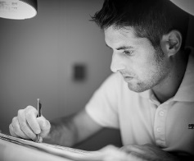
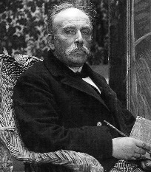
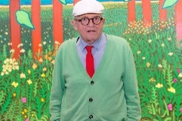
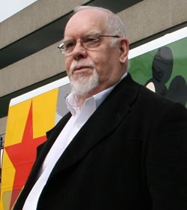
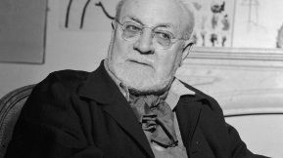

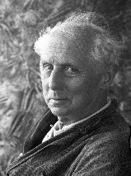
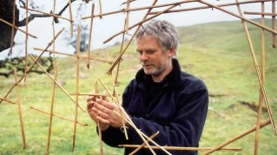
Digital Art
 | EYFS | KS1 | LKS2 | UKS2
Focus Objectives | Explore a digital paint programme on the laptop or IWB | Create a picture in the paint programme  Explore shapes, fill tools, copy & paste, selection, cropping and brush tools | Integrate a photo into a work of art  Explore ideas through digital sources  Use an ICT programme to combine their work with someone else’s | Combine images using digital technology  Understand the importance of balance, contrast and pattern
Key Vocabulary | Laptop, IWB, | Shape, fill, copy, paste, select, crop, brush, | Combine, integrate, | Combine, balance, contrast pattern,
Resources | Laptops, IWB, | Laptops, paint programme, | Cameras, laptops, | As LKS2
Focus Artists |  | Harold Cohen, Frieder Nake, | Jeff Wall, | David Hockney, Andreas Gursky,
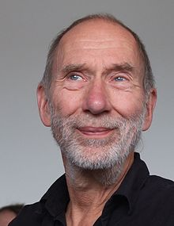
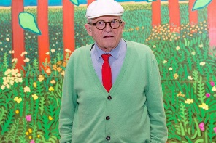
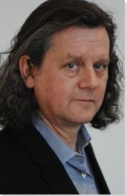
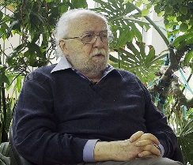

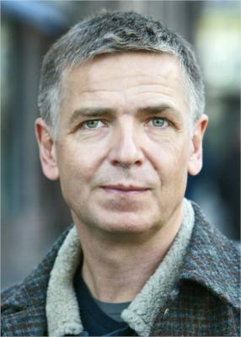

Drawing
 | EYFS | KS1 | LKS2 | UKS2
Focus Objectives | Use lines to enclose a shape  Use shapes to represent  Talk about intention  Combine different media  Work on different scales  Work alone and in a group  Use lines of different thicknesses | Draw from observation, memory and imagination  Begin to understand sketching  Use hatching, scribbling and stippling to create tone  Use different grades of pencils  Draw landscapes and portraits  Explore line and mark making  Use smudging, blending & rubbing techniques  Begin to understand shading | Draw outlines  Draw with detailed and intricate marks  Compare different artists  Focus on facial expression in portraits  Focus on tone  Investigate pressure  Sketch at speed  Create a sequence of pictures | Work on a sustained drawing with an increasing level of detail  Draw from close observation but also influenced by stories and myths  Work on different scales and proportions  Experiment with techniques used by different artists  Use shading, hatching and blending within works  Show perspective through tonal contrast and depth
Key Vocabulary | Line, shape, thick, thin, | Sketch, portrait, observation, memory, imagination, shade, tone, line, mark making, smudge, blend, rub, copy, enlarge, hatch, scribble, stipple, | Tone, outline, pressure, | Tonal contrast, depth, shading, hatching, blending, scale, proportion,
Resources | Felt-tips, coloured pencils, gel pens, wax crayons, highlighters, watercolour pencils, stencils, colour change pens, | Pencils, soft pastels, charcoal, chalk, | As KS1 + ball point pens, oil pastels, | As LKS2 + drawing inks, fine-liners,
Focus Artists |  | Pablo Picasso, Frank Auerbach, L.S. Lowry, Edgar Degas | Rembrandt | Pieter Bruegel the Elder, Beatrix Potter, MC Escher,
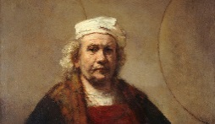
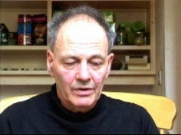
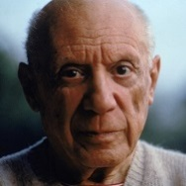
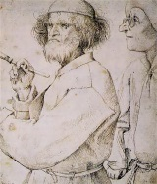
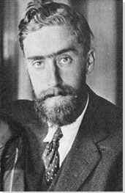

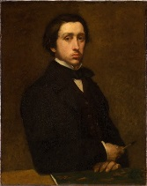
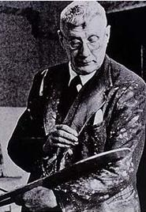
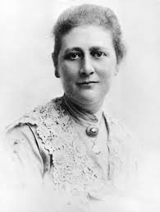
Painting
 | EYFS | KS1 | LKS2 | UKS2
Focus Objectives | Learn how to grip tools and brushes correctly  Use a range of paints  Use a range of items to apply paint  Paint freely  Name and choose colours  Paint from observation, memory and imagination  Paint with no outline  Learn how to clean brushes | Name primary and secondary colours  Create a simple colour wheel  Explore colour spectrums- collect colours  Mix with powder paint  Explore thick and thin paint  Use a viewfinder  Use a range of brushes, found objects and paints  Explore wet and dry techniques  Make backgrounds | Create a colour wheel with concentric circles  Understand hues, tints, shades, warm/cool colours, harmonising colours and complementary colours  Mix browns, neutrals and flesh colours  Explore colour blocking  Explore sponging and stippling  Work in the style of different artists  Represent light and dark  Make and match colours  Compare different artists  Create a colour wash  Use dirty water for outlines  Explore thin paint and Brusho  Work over an extended period of time on one piece  Explore overpainting, resist and layering | Mix all colours from primary and mix blacks  Work with a limited colour palette- 1 colour with tints and shades  Build up a painting in stages  Understand background, middle and foreground  Use a viewfinder  Use scraping, overpainting, resist and layering in artworks  Paint from observation  Show texture, perspective, atmosphere and light effects  Work on different scales and proportions  Combine painting with collage  Explore paint consistency  Work on different surfaces
Key Vocabulary | Colour names, outline, brush, | Primary, secondary, spectrum, lighten, darken, landscape, texture, background, additives, wet, dry, | Sponging, stippling, hue, shade, harmonising, complementary, concentric, tint, warm, cool, neutrals, flesh, thicken, colour blocking, light, dark, match, wash, overpainting, resist, layering, | Middle ground, foreground, scraping, perspective, atmosphere, light effects, tints, shades, stages, overpainting, resist, layering, texture, scale, proportion, consistency,
Resources | Ready mixed paints, brushes, glitter paint, sponges, paint spinner, glow in the dark paint, toothbrushes, powder paint, watercolour pencils, | Primary colour powder paint, range of brushes, palette knives, water-colour blocks, | As KS1 + secondary colour powder paint, watercolours, Brusho, water-soluble pastels, | As LKS2 + oils, acrylics, metallic pens, paint pens,
Focus Artists |  | Piet Mondrian, Jackson Pollock, Mari French, Claude Monet, | Mark Rothko, Wassily Kandinsky, Georges Seurat, Roy Lichtenstein, Vincent Van Gogh, Leonardo Da Vinci, Romero Britto, | JMW Turner, John Constable,
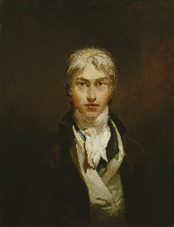
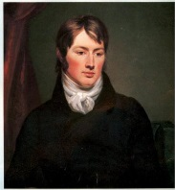
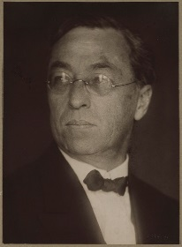
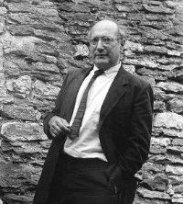
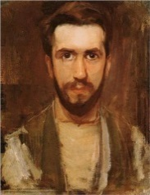
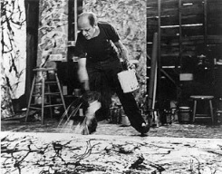

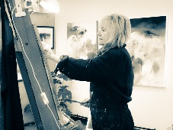
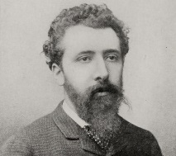
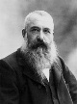
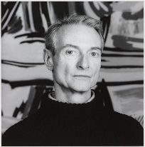

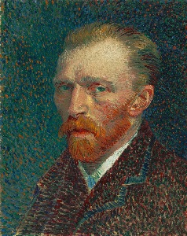

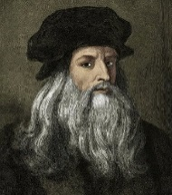

Photography
 | EYFS | KS1 | LKS2 | UKS2
Focus Objectives | Take a photo using the camera | Take a photo using the zoom function  Recognise photos as a form of art  Take photos for a theme | Explore 3d, perspective and reflections  Take photos from unusual viewpoints  Understand viewpoints  Create a sequence of pictures  Integrate a photo into a work of art | Understand the importance of balance, contrast and pattern  Create a photomontage  Create a mixed media collage
Key Vocabulary | Photo, press, camera, button, | Zoom, theme, | Viewpoint, 3d, perspective, reflection, integrate, | Balance, contrast, pattern, photomontage, mixed media,
Resources | Cameras, | As EYFS, | As EYFS + other previously used art resources | As EYFS + other previously used art resources
Focus Artists |  | Emily Turner, Ansel Adams, | Anna Atkins, Julia Margaret Cameron, Fay Godwin, Jeff Wall, | David Hockney, Peter Blake, Maria Rivans, Andreas Gursky,
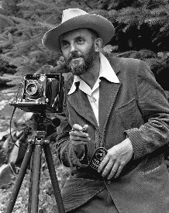
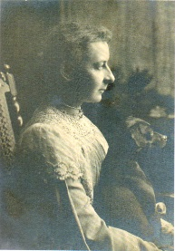
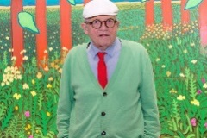
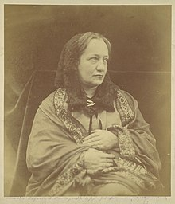

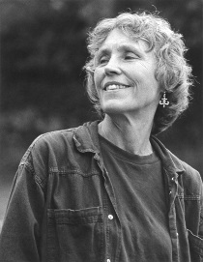

Printmaking
 | EYFS | KS1 | LKS2 | UKS2
Focus Objectives | Explore body prints  Explore accidental colour mixing  Use stamps, sponges, stencils and rubbings  Use the ‘dip and apply’ method  Begin to recognise patterns  Print to create images and patterns  Print with left to right movements | Explore overprinting for colour mixing  Explore marbling  Create own stamps for relief printing using string and card  Recognise where prints are used in real life  Create 1 colour, repeat prints  Print with a range of tools  Understand how to work cleanly  Create straight line prints without a grid | Use readymade printing blocks to create 2 colour prints  Use a roller cleanly and effectively  Use stencils for printing  Create 3 colour patterns by overprinting  Use photos/digital images within prints | Explore mono-printing  Create surface texture  Explore masking when mono-printing  Explore positive and negative space  Use 3 or more colours when overprinting  Design and make their own block
Key Vocabulary | Finger, hand, foot, mix, stamp, sponge, stencil, rub, dip, pattern, | Overprint, marbling, mono-printing, relief, repeat, print, grid, | roller, block, stencil, overprinting, pattern, | Surface texture, masking, positive space, negative space, mono-printing,
Resources | Ready mixed paints, brushes, ink stampers, foam stampers, finger paints, sponges, | marbling inks, ready mixed paints, string, card, wet glue, | Printing blocks, printing inks, rollers, ink trays, stencils, cameras, laptops, | As LKS2 + Textured materials, polystyrene tiles, pencils, bin bags, masking tape,
Focus Artists |  | Natalie Stopka, | William Morris, Andy Warhol, Banksy, | Helen Frankenthaler, Katsushika Hokusai,
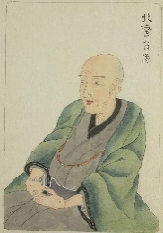
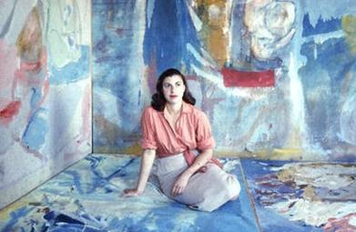
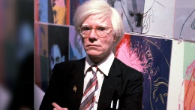
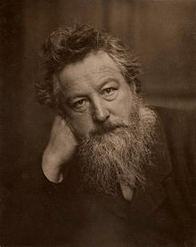
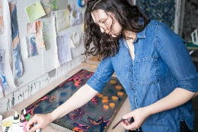

Sculpture
 | EYFS | KS1 | LKS2 | UKS2
Focus Objectives | Handle and describe 3d objects  Stack and balance 3d shapes  Construct horizontally  Work with construction kits  Use scissors effectively  Choose best joining methods  Use glue cleanly and effectively  Choose resources by shape and texture  Build for height and width | Understand shape, form and texture  Collect for a theme  Use glue, paste and tape as appropriate  Fold, cut, tear and curl paper and card  Use found materials | Explore new joining techniques- slotting, tying, pinning, tabs, weaving and sewing  Create small scale box models  Use tools, scissors and cutters  Make formers using boxes or rolled paper  Construct simple assemblages  Apply surface decoration | Use moulds to make masks  Explore lamination, Modroc and collage for surface texture  Use Modroc for texture, decoration and skins  Work in relief  Make large scale box models  Explore positive and negative space  Create natural structures  Use chicken wire or willow sticks as a former  Construct scale models
Key Vocabulary | 3d, tall, wide, feel, texture, shape names, | Shape, form, texture, fold, cut, tear, curl, theme, | Slotting, tying, pinning, weaving, sewing, former, assemblage, small scale, surface, decoration, | Mould, lamination, Modroc, collage, surface texture, decoration, skins, relief, large scale, positive space, negative space, natural structure, former, scale,
Resources | glue sticks, wet glue, sellotape, masking tape, junk modelling resources, pipe cleaners, lolly sticks, match sticks, lego, mobilo, paper clips. | glue sticks, wet glue, sellotape, masking tape, junk modelling resources, | KS2 scissors box, KS1/2 collage box, paper for final collage (range of sizes and colours available), paper punches, | Mask moulds, Modroc, willow sticks,
Focus Artists |  | Brendan Jamison, Michelle Reader, | Joseph Cornell, Jill Townsley, Zim and Zou, People Too, Maud Vantours, | Romuald Hazoume, Julie, Taymor, Barbara Hepworth, Henry Moore, Louise Bourgeois,
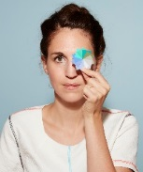
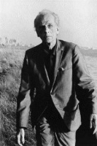
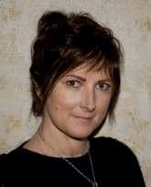
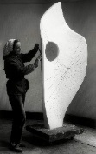
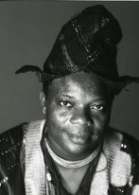
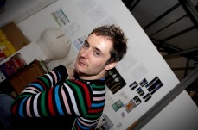
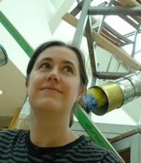

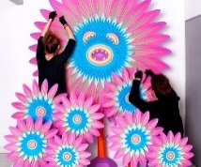
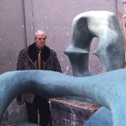
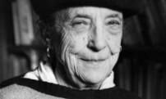
Textiles
 | EYFS | KS1 | LKS2 | UKS2
Focus Objectives | Collect and sort materials for a purpose e.g. colour, texture  Explore over and under weaving  Decorate fabric  Explore simple stitch work | Create a group weaving  Explore fabric, string and yarns  Use scissors effectively  Explore tying, untying, twisting and plaiting  Explore dyeing (natural/food dyes) and peg tie dye  Thread needles and beads  Use running stitch on binka/hessian  Add buttons | Sew on binka  Use cross stitch and other mark making through sewing  Explore 2 colour tie dye with string/elastic bands  Explore applique  Use embroidery techniques to decorate  Print on fabric  Try patchwork | Use sewing techniques to join paper and card  Use textiles within collage work  Use a range of basic stitches  Paint or print on fabric  Explore soft sculpture  Use printing as a starting point for embroidery  Work collaboratively
Key Vocabulary | Collect, sort, colour, texture, under, over, weave, fabric, stitch, | Fabric, string, yarn, thread (cotton), tie, untie, plait, twist, weave, dye, running stitch, thread (needle) | Cross stitch, applique, embroidery, patchwork, | Batik, soft sculpture, embroidery,
Resources | Raffia, wool, ribbon, beads, fabrics, buttons, needles, binka/hessian, felt flowers, | Weaving looms, fabrics, beads, plastic canvas, buttons, needles, threads/wool, natural dyes, | Binka, fabric pens/paints/crayons, iron, fabric scraps, needles, thread, fabric to dye, tie dye kit, elastic bands/string, | laptops, iPads, scrap paper, felt, needles, embroidery threads, fabric paints, toy stuffing,
Focus Artists |  | Anni Albers, Ann Carrington, | Alighiero Boetti, Abigial Mill, | Lucy Sparrow,
